Before reading this document you should read, and make sure you are familiar with the concepts covered in, the lecture notes regarding Introduction to VBA (lecture week 9).

In this document we are only concerned with using the commandbutton to run a query. We use the Wizard to create the commandbutton for this purpose, describe the steps required to instruct the Wizard accordingly, and describe the steps necessary to inspect and change the VBA procedure code created by the Wizard.

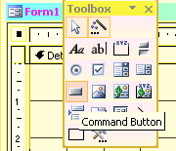
With your form in design view, with the Control Wizards enabled, select the Command Button tool (see Figure 1) and place it onto the form (dragging the cursor to create an appropriately sized commandbutton).

Figure 1: Form toolbox showing the Command Button tool.

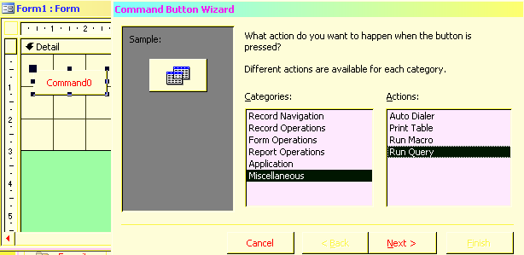
The Command Button Wizard should appear. From the list of available Categories select Miscellaneous and from the list of available Actions select Run Query. Your form should appear as in Figure 2.

Figure 2.
Command Button Wizard with option selected to Run Query

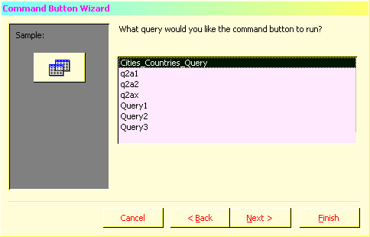
Select Next.

From the list of available queries (the queries displayed in the list will depend on the queries you have already created and saved in your database) select the query that you want to run when the user clicks the Command Button. See Figure 3 for a typical list of available queries.

Figure 3.
Command Button Wizard showing typical list of queries.

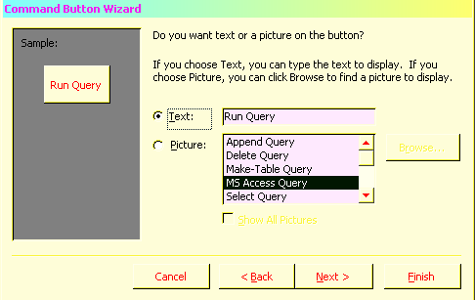
Select Next.

Your command button can either show Text or a Picture. Select the desired option using the radio buttons, as in Figure 4.
The Text option allows you enter your own text in the adjacent box.
The Picture option allows you to select from a range of available images.

Figure 4.
Command Button Wizard showing Text or Picture option.

Select Next (Or Finish).

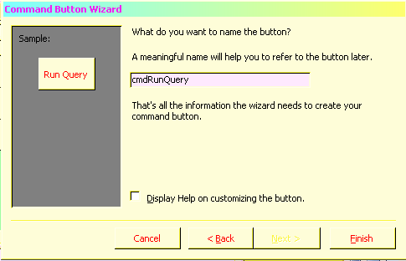
In the final step, you name your command button (if you select Finish at the previous step the Wizard generates a name, e.g. Command0). It is advisable to use a name that you will easily recognize in the next phase of inspecting and changing the VBA procedure code created by the Wizard. See Figure 5.

Figure 5.
Command Button Wizard: entering name for command button.

Select Finish.

We now describe how to inspect and change an event procedure created by the Command Button Wizard on a form.
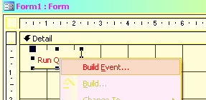
In form Design view, right-click the command button created by the Command Button Wizard.
On the shortcut menu, click Build Event. See Figure 6.

Figure 6. Shortcut menu to access VBA event procedure.

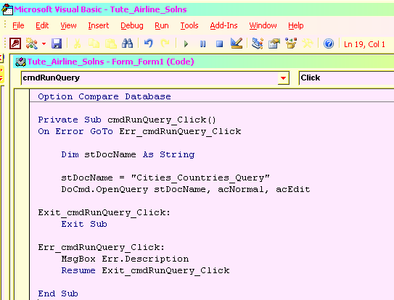
The Microsoft Visual Basic editor window appears showing the VBA event procedure code created by the Command Button Wizard. See Figure 7.

Figure 7. VBA event procedure created by Command Button Wizard.

Note the options used for the command to open the query: stDocName, acNormal and acEdit.
stDocName holds the name of the query to run – in this case “Cities_Countries_Query” select at Figure 3 above)
acNormal indicates the query should be opened in Normal View.
acEdit indicates the query should be opened in Edit Mode.

To change the options used for the command to open the query, click at the end of the line that performs the action of opening the query (“DoCmd.OpenQuery stDocName, acNormal, acEdit”).
Use the backspace key until you have deleted the option(s) you wish to change including the preceding comma(s).
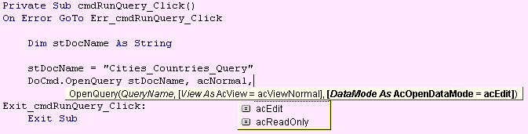
As you start to re-enter the option(s) – including the preceding comma(s) – the system offers a list of the options available along with a context sensitive description of the option being entered. Select the appropriate option(s).

Close the editor, close and save your form.

